**Teacher Notes for “****Plant Growth Puzzle**

**– Photosynthesis, Biosynthesis, and Cellular Respiration”**[1]

This minds-on analysis and discussion activity challenges students to explain changes in biomass for plants growing in the light vs. dark. Students analyze how photosynthesis, biosynthesis, and cellular respiration affect biomass. These Teacher Notes suggest three possible additions to this activity that expand student understanding of photosynthesis, cellular respiration, hydrolysis of ATP, biosynthesis, and starch.

Before your students begin this activity, they should have a basic understanding of photosynthesis and cellular respiration. For this purpose, I recommend the analysis and

discussion activities:

* How do organisms use energy? (<https://serendipstudio.org/exchange/bioactivities/energy>)
* Using Models to Understand Cellular Respiration

(<https://serendipstudio.org/exchange/bioactivities/modelCR>)

* Using Models to Understand Photosynthesis (<https://serendipstudio.org/exchange/bioactivities/modelphoto>)

A possible alternative hands-on activity that covers much of the same material is “Photosynthesis, Cellular Respiration and Plant Growth” (<https://serendipstudio.org/sci_edu/waldron/#photobiomass>). This hands-on activity begins with the question of how a tiny seed grows into a giant Sequoia tree. To answer this question, students analyze data from research studies on plant biomass, and they conduct a hands-on experiment to evaluate changes in CO2 concentration in the air around plants in the light vs. dark. Students interpret the data to understand how photosynthesis makes an essential contribution to increases in plant biomass, and cellular respiration can result in decreases in biomass. An inquiry, hands-on activity which develops the same concepts is presented in "An Inquiry-based Approach to Teaching – Photosynthesis and Cellular Respiration" by Dan O'Connell, American Biology Teacher 70(6): 350-6, 2008.

**Table of Contents**

Learning Goals – pages 1-2

Instructional Suggestions and Background Information – pages 2-7

Additional Information – page 7

Optional Additions to this Activity

Storyboards – pages 8-10

Chemical Equations for Photosynthesis and Cellular Respiration – pages 11-13

Diurnal Variation of Starch in Leaves – page 14

**Learning Goals**

In accord with the Next Generation Science Standards[2]:

* Students learn the following Disciplinary Core Ideas:
* LS1.C: "The process of photosynthesis converts light energy to stored chemical energy by converting carbon dioxide plus water into sugars plus released oxygen. The sugar molecules thus formed contain carbon, hydrogen, and oxygen; their hydrocarbon backbones are used to make amino acids and other carbon-based molecules… Cellular respiration is a chemical process whereby the bonds of food molecules and oxygen molecules are broken”, carbon dioxide and water are formed, and the energy released is used in the production of ATP from ADP and P. Then, the hydrolysis of ATP molecules provides the energy needed for many biological processes.
* Students engage in recommended Scientific Practices, including Constructing Explanations: Apply scientific ideas, principles, and/or evidence to provide an explanation of phenomena…”
* This activity can be used to illustrate the Crosscutting Concepts:
  + “Energy and matter: Flows, Cycles and Conservation” – “matter is conserved because atoms are conserved in physical and chemical processes… Energy may take different forms…”
  + “Cause and Effect: Mechanism and Prediction” – Students “suggest cause and effect relationships to explain and predict behaviors in complex natural and designed systems”.
* This activity helps students to prepare for Performance Expectations:
* HS-LS1-5, "Use a model to illustrate how photosynthesis transforms light energy into stored chemical energy."
* HS-LS1-7, "Use a model to illustrate that cellular respiration is a chemical process whereby the bonds of food molecules and oxygen molecules are broken and the bonds in new compounds are formed resulting in a net transfer of energy."
* HS-LS2-5, "Develop a model to illustrate the role of photosynthesis and cellular respiration in the cycling of carbon among the biosphere, atmosphere…”

This learning activity will help to counteract two common misconceptions.[3]

– Many students believe that only animals carry out cellular respiration and plants only carry out photosynthesis. They do not understand that plants also need to carry out cellular respiration to provide ATP for cellular processes.

– Many students don’t understand the importance of photosynthesis and find it hard to believe that the biomass of plants comes largely from a gas (CO2).

**Instructional Suggestions and Background Information**

To maximize student participation and learning, I suggest that you have your students work in pairs (or individually or in small groups) to answer groups of related questions and then have a class discussion after each group of related questions. In each discussion, you can probe student thinking and help them to develop a sound understanding of the concepts and information covered before moving on to the next group of related questions.

If your students are learning online, we recommend that they use the Google Doc version of the Student Handout available at <https://serendipstudio.org/exchange/bioactivities/photocellrespir>. To answer questions 5 and 10, students can either print the relevant page, draw on it and send you a picture, or they will need to know how to modify a drawing online. To answer online, they can double-click on the relevant drawing in the Google Doc to open a drawing window and use the editing tools to add shapes.

You may want to revise the GoogleDoc or Word document to prepare a version of the Student Handout that will be more suitable for your students. If you use the Word document, please check the format by viewing the PDF.

A key for the Student Handout and all three of the optional additions shown at the end of these Teacher Notes is available upon request to Ingrid Waldron ([iwaldron@upenn.edu](mailto:iwaldron@upenn.edu)). The following paragraphs provide additional instructional suggestions and background information.

At the beginning of the Student Handout, students are introduced to the concept of biomass, which is the mass of the organic molecules in a plant. Organic molecules are complex, carbon-containing molecules found in living organisms.

The photograph on page 1 of the Student Handout introduces the experiment which is the focus of this activity. You may want to project this photograph in color, since it is clearer in color. Students may notice that, after ten days, the plants in no light are paler (less green) than the plants in light. Plants respond to light by producing more chloroplasts with more chlorophyll. The differences between plant development in the light and dark are controlled by complex molecular processes that involve phytochrome molecules that respond to light and plant hormones (e.g. auxin and giberellins) that control transcription factors.

Notice that the plants in the experiment were grown in petri dishes with water, but no soil. This observation can be used to reinforce the important concept that most of a plant’s biomass comes from the air (CO2) and relatively little from the minerals in the soil. For additional information and a learning activity, see "Where does a tree's mass come from?" (<https://serendipstudio.org/exchange/bioactivities/plantmass>). After the minerals stored in the seed have been used, minerals from the soil would be required in order for growth to continue.

Questions 1-2 ask students to predict the change in biomass in each experimental condition and give a reason for each prediction. The goal is for each student or group of students to use what they know thus far to make a prediction that they can support with a reasonable, logical explanation. You may want to probe your students’ thinking, but please don’t reveal the correct answers as you discuss these questions; instead, allow your students to discover the correct answers as they work their way through the rest of the activity.

|  |  |
| --- | --- |
| Sophisticated students could reasonably respond that there is not enough information to choose the answer for the first blank in question 2. The green line in this graph shows that peas sprouting in the light initially lose biomass (dry mass). Biomass of the seedlings in the light does not begin to increase until these seedlings have developed the capacity for photosynthesis. | (Figure from "An Inquiry-based Approach to Teaching – Photosynthesis and Cellular Respiration" by Dan O'Connell, American Biology Teacher 70(6): 350-6, 2008) |

Pages 2-4 of the Student Handout analyze the reasons for the actual results.[4] You may want to omit the data from line 2 of the table in question 3a, and only provide the data after the students have completed questions 1-2.

|  |  |  |  |
| --- | --- | --- | --- |
|  | Light, no water | Light, water | Water, no light |
| Biomass after 10 days | 1.46 g | 1.63 g | 1.20 g |

Page 2 of the Student Handout introduces the concept of biosynthesis. The glucose molecules produced by photosynthesis are used for the synthesis of other organic molecules in plants. The figure below provides some additional information about how glucose is used to synthesize a variety of organic molecules.

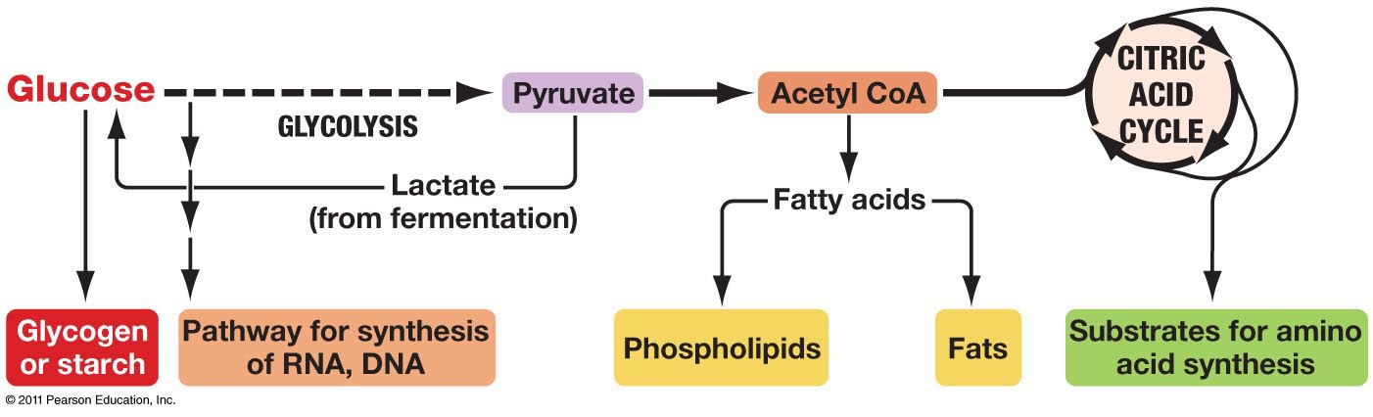

(<http://www.uic.edu/classes/bios/bios100/lectures/09_28_anabolic_pathways-L.jpg> )

The bottom figure on page 2 of the Student Handout shows that glucose monomers are joined in different ways in cellulose and starch polymers. This difference in how the glucose monomers are linked results in different shapes for these polymers. Starch molecules have a helical or branched form. In contrast, cellulose molecules are straight and cross-linked by hydrogen bonds to form microfibrils that give strength to plant cell walls. Animals can digest starch, but not cellulose (although the guts of ruminants and termites contain microorganisms that can digest cellulose).

The figure below provides some additional information about starch synthesis.[5] Notice that:

* The synthesis of starch requires ATP; this is an example of how ATP provides the energy needed for the synthesis of molecules.
* The synthesis of starch requires enzymes.
* Glucose monomers are added one at a time to synthesize the starch molecule.

(These points are also relevant for the synthesis of other biological polymers.)

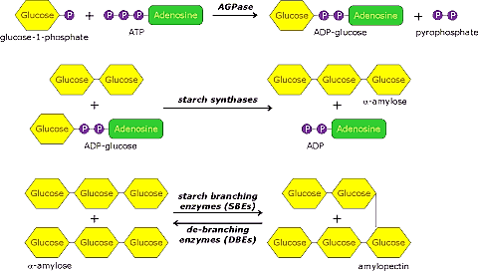

(<http://www.andrewgray.com/essays/starchp.gif>)

Starch synthesis is useful for storing glucose to be used for cellular respiration in future situations where photosynthesis cannot occur. For example, starch is stored:

* in seeds for use when seedlings first sprout
* in tubers for use in generating a plant after a cold or dry season
* in leaves during the day to provide glucose for cellular respiration during the night (see the last page of these Teacher Notes).

A plant needs nitrogen and phosphorus from soil water in order to synthesize amino acids, nucleotides, and phospholipids. The figure below illustrates this generalization for amino acids.

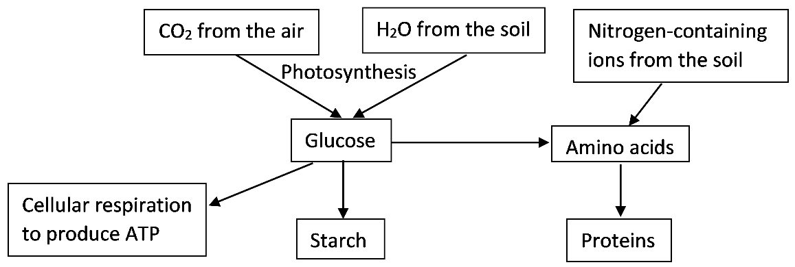

The figure on the top of page 3 of the Student Handout follows the usual convention that photosynthesis produces glucose. In reality, photosynthesis directly produces a three-carbon molecule, glyceraldehyde-3-phosphate, which plant cells use to synthesize glucose and fructose. Some of the glucose and fructose are used to make sucrose which is transported to other parts of the plant.

As you know, hydrolysis refers to a chemical reaction in which a molecule is split into smaller molecules by reacting with water. Students may be less familiar with this term and may need help to recall this definition. This figure shows the hydrolysis of ATP.

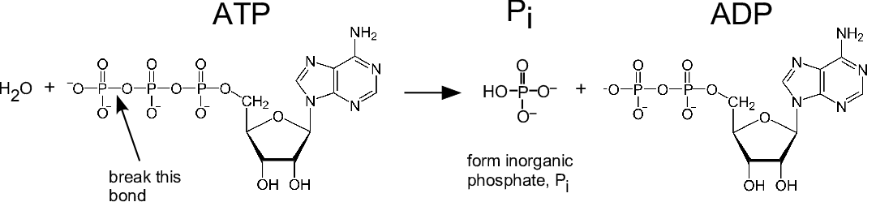

A small amount of energy is required to cleave the terminal phosphate from ATP, but more energy is released when this phosphate combines with water to form the hydrogen phosphate ion (HPO4–). This is often referred to as simply phosphate (abbreviated as P or Pi). (The figure omits the H+ ion which is produced by the dissociation of the weak acid H2PO4– 🡪 H+ + HPO4–.)

The Student Handout does not mention that the hydrolysis of ATP usually occurs after part of the ATP has bound with a substrate molecule (e.g. one of the reactants in a synthesis reaction). (See the figure showing starch synthesis on the previous page.) This is how the exergonic hydrolysis of ATP is coupled with the endergonic the synthesis reaction.

Question 8 can be used to help students understand several important points:

* Cells can not directly use sunlight or glucose to provide the energy for most biological processes. Therefore, all organisms (including plants) need to make ATP which can provide energy in the form needed to carry out many cellular processes (e.g. synthesis of organic molecules or pumping substances into and out of cells).
* Most organisms (including plants) carry out cellular respiration to produce ATP.[6]
* All organisms need a source of organic molecules for cellular respiration, but plants use photosynthesis to make organic molecules, whereas animals eat food to get organic molecules.

In your discussion of energy, you should be aware that, although it is common to describe chemical energy as stored in glucose, it is more accurate to describe chemical energy as a property of the system of glucose and O2 which interact to produce CO2 and H2O. This point is illustrated by the contrast between the larger amount of ATP produced by aerobic cellular respiration of glucose vs. the much smaller amount of ATP produced by anaerobic fermentation of glucose in the absence of O2 (see “How do muscles get the energy they need for athletic activity?” <https://serendipstudio.org/exchange/bioactivities/energyathlete>). In discussing cellular respiration and hydrolysis of ATP, it is important to remember that breaking bonds always requires energy input and energy is released only when new more stable bonds are formed. Expanded explanations of these points are provided in “Cellular Respiration and Photosynthesis – Important Concepts, Common Misconceptions, and Learning Activities” (<https://serendipstudio.org/exchange/bioactivities/cellrespiration>).

|  |  |
| --- | --- |
| This figure shows a more complete version of the lower figure on page 4 of the Student Handout. Notice that:  ∙ The enzyme that digests starch is secreted by the embryo plant.  ∙ Maltose is the main sugar that is actually absorbed by the embryo plant. The embryo plant cleaves maltose into two glucose molecules. | Diagram  Description automatically generated  seed  (modified from <https://slideplayer.com/slide/13124647/79/images/7/Enzymes+are+used+in+seed+germination.jpg>) |

The fact that there was no significant change in the biomass of the dry seeds reflects their dormant condition in which very little cellular respiration and no photosynthesis is occurring.

Question 11 asks students to explain the seeming discrepancy between the greater total mass of the plants in the “water, no light” condition vs. the greater biomass of the seeds in the “light, no water” condition. The plants in the “water, no light” condition lost biomass due to the effects of cellular respiration without photosynthesis. However, they gained water which resulted in greater total mass. Approximately 75% of the mass of actively growing plants is water.

Sources for figures in Student Handout

* page 1 – From Ebert-May et al., Disciplinary Research Strategies for Assessment of Learning, BioScience 53:1221-8, 2003
* page 2, starch and cellulose – modified from <https://classconnection.s3.amazonaws.com/954/flashcards/1172954/jpg/biopic1328807784092.jpg>
* pages 3-4 – modified from <https://bodell.mtchs.org/OnlineBio/BIOCD/text/chapter7/concept7.1.html>
* page 4 – modified from <https://slideplayer.com/slide/13124647/79/images/7/Enzymes+are+used+in+seed+germination.jpg>

Optional Additional Activities

Three possible add-ons for this activity are given in the pages that follow. Additional background and learning activities are provided in “Cellular Respiration and Photosynthesis – Important Concepts, Common Misconceptions, and Learning Activities” (<http://serendipstudio.org/exchange/bioactivities/cellrespiration>).

**Teacher Notes for Storyboards**

To help students consolidate their understanding of photosynthesis and cellular respiration, you can use a modified version of storyboarding[7], as follows:

* Before students begin the Student Handout, students work in pairs and use their background knowledge to respond to the Introductory Photosynthesis and Cellular Respiration Storyboard (shown on page 9 of these Teacher Notes). This will help to activate students’ memory of relevant concepts and information. I recommend that you review these initial storyboards to learn more about your students’ knowledge and any misconceptions they may have. This storyboard is intended for formative assessment only.
* As students increase their understanding of photosynthesis and cellular respiration during the activity, they can modify their Introductory Storyboards.
* After completing the activity presented in the Student Handout, students complete the Follow-up Storyboard (shown on page 10 of these Teacher Notes) without looking at their introductory storyboard or the Student Handout. After they complete the Follow-up Storyboards, students should have prompt feedback so they can improve the accuracy and completeness of their storyboards; you can accomplish this in a class discussion where students compare their storyboards. This type of active recall with feedback helps to consolidate student understanding and retention of the concepts learned during the activity.[8]

**Introductory Photosynthesis and Cellular Respiration Storyboard**

**1.** For each figure on the left, write the name of the process in the rectangle.

**2.** Draw lines to connect each molecule that is the same in the upper and lower figures in the left-hand column.

**3.** Describe what is happening in each of the four figures shown. Use terms such as:

carbon dioxide, cellular respiration, cellulose, glucose, hydrolysis of ATP, oxygen, photosynthesis, provides the energy for many biological processes, water.

**4.** Note any questions you have.

|  |  |
| --- | --- |
| http://apps.cmsfq.edu.ec/biologyexploringlife/units/unit8/..%2F../text/chapter7/07images/07-03.gif |  |
| http://apps.cmsfq.edu.ec/biologyexploringlife/units/unit8/..%2F../text/chapter7/07images/07-03.gif  **ADP + P**  **ATP + H2O** |  |

**Follow-up Photosynthesis and Cellular Respiration Storyboard**

**1.** Fill in the blanks to show an overview of photosynthesis.

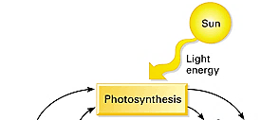

____________ ____________ ___________ ______________

**2.** Add to your diagram to show cellular respiration and how cellular respiration is related to photosynthesis.

**3.** Add to your diagram to show how ATP provides energy for many biological processes. Show how this reaction is related to cellular respiration.

**4.** Sometimes the rate of photosynthesis exceeds the rate of cellular respiration, so some of the glucose molecules produced by photosynthesis are not used for cellular respiration. Add to your diagram to show what happens to the glucose molecules that are produced by photosynthesis and are not used for cellular respiration.

**Teacher Notes for “Chemical Equations for Photosynthesis and Cellular Respiration”[9]**

Both photosynthesis and cellular respiration consist of multiple chemical reactions which are summarized in the chemical equations the students will prepare to answer the questions on the next page. This page could be inserted after question 8 in the Student Handout.

If your students are familiar with the terms exergonic and endergonic (or exothermic and endothermic), you can substitute those terms for energy-releasing and energy-consuming in question 10c in this potential add-on activity.

After discussing the questions on the next page, you may want to have your students compare and contrast the diagrams of photosynthesis and cellular respiration that they have developed in their answers to these questions with the diagram shown in the figure on page 3 of the Student Handout.

Supplies

Each student or pair of students will need a piece of paper that they can tear or cut into 16 rectangles and label these rectangles as directed on the next page. If you prefer, you can print copies of page 13 of these Teacher Notes, cut each page in thirds, and have students write the names of the molecules in the first column and then cut out the rectangles.

**Student Handout Insert for “Chemical Equations for Photosynthesis and Cellular Respiration”**

To represent the overall chemical equations for photosynthesis and cellular respiration, you will use 16 rectangles. Divide a sheet of paper into 16 rectangles.

For photosynthesis, prepare:

* four rectangles, each with one of the following: C6H12O6, 6 CO2, 6 H2O, 6 O2.

Write the name of the molecule represented by each chemical formula

* two rectangles with +
* one rectangle with ––––→ to represent the chemical reactions of photosynthesis
* one rectangle with sunlight

For cellular respiration, you will need all of the photosynthesis rectangles except the last, plus:

* four rectangles, each with one of the following: ~29 ATP, ~29 ADP, ~29 P, ~29 H2O
* two additional rectangles with +
* one rectangle with ––––→
* one rectangle with two curved arrows

**9.** Arrange the eight rectangles for photosynthesis to summarize the chemical reactions for photosynthesis. Copy this chemical equation into the top box in this chart.

Photosynthesis

Cellular Respiration

**10a.** To show cellular respiration, begin by rearranging the photosynthesis rectangles (except for sunlight) to summarize how glucose and oxygen react to form carbon dioxide and water.

**10b.** Beneath that, arrange the other rectangles (except for the curved arrows) to summarize how ATP is synthesized from ADP + P.

**10c.** Replace both straight arrows with the pair of curved arrows to indicate that these two sets of chemical reactions are coupled reactions, with energy transfer from the first energy-releasing reaction to the second energy-consuming reaction.

**10d.** Copy these chemical equations into the bottom box in the above chart.

**11.** Draw two dashed arrows to show how the products of photosynthesis can be used as inputs for cellular respiration. Then, draw two dashed arrows to show how two of the products of cellular respiration can be used as the inputs for photosynthesis.

Pieces for Three Students or Pairs of Students for Page 12

|  |  |  |  |
| --- | --- | --- | --- |
| C6H12O6 | + | ~29 ATP | + |
| 6 CO2 | + | ~29 ADP | + |
| 6 H2O | ––––→ | ~29 P | ––––→ |
| 6 O2 | sunlight | ~29 H2O |  |

|  |  |  |  |
| --- | --- | --- | --- |
| C6H12O6 | + | ~29 ATP | + |
| 6 CO2 | + | ~29 ADP | + |
| 6 H2O | ––––→ | ~29 P | ––––→ |
| 6 O2 | sunlight | ~29 H2O |  |

|  |  |  |  |
| --- | --- | --- | --- |
| C6H12O6 | + | ~29 ATP | + |
| 6 CO2 | + | ~29 ADP | + |
| 6 H2O | ––––→ | ~29 P | ––––→ |
| 6 O2 | sunlight | ~29 H2O |  |

**Teacher Notes** **for “Diurnal Variation of Starch in Leaves”**

The figure below shows the diurnal fluctuation of starch levels in leaves of coleus. During daylight hours, photosynthesis produces glucose, and some of the glucose is stored in starch. During the night, starch is broken down to provide the glucose needed for cellular respiration. Therefore, starch levels in leaves tend to be highest at the end of daylight and lowest at the end of the night.

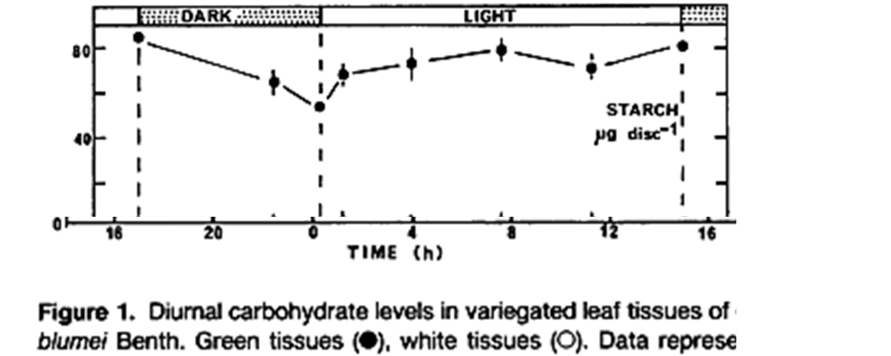

(Source: “Carbohydrate metabolism in photosynthetic and non-photosynthetic tissues a variegated leaves of *Coleus blumei* Benth.”

Plant Physiology (1990) 93:617-622.)

You may want to insert the following questions after question 10 in the Student Handout or you may want to use these questions for summative assessment.

For Student Handout:

A plant needs to carry out cellular respiration throughout the day and night in order to produce the ATP which provides the energy needed for the processes of life. Photosynthesis produces glucose which is needed for cellular respiration.

When photosynthesis produces more glucose than the plant needs, the excess glucose is stored in starch molecules. Starch molecules can be broken down to provide glucose when glucose is needed for cellular respiration.

**11a.** The reversible reaction shown below takes place in leaves. Label each arrow with “day” or “night” to show the expected direction of this reaction in the light or dark.

multiple glucose molecules starch molecule

**11b.** Do you think that leaves have more starch molecules at the end of daylight or at the end of the night? Explain your reasoning.

**12a.** In the dark, a plant gives off CO2 to the air around it. Explain why.

**12b.** In the light, a growing plant takes in more CO2 than it produces. Explain why. Where do the carbon atoms from the CO2 go?

1. By Dr. Ingrid Waldron, Department of Biology, University of Pennsylvania, 2024. TheseTeacher Notes and the related Student Handout are available at <https://serendipstudio.org/exchange/bioactivities/photocellrespir>.
2. Quotations are from <https://www.nextgenscience.org/> and <http://www.nextgenscience.org/sites/default/files/HS%20LS%20topics%20combined%206.13.13.pdf>
3. Misconceptions are from <https://www.learner.org/vod/vod_window.html?pid=77> and Hard-to-Teach Biology Concepts, page 135, by Susan Koba with Ann Tweed.
4. These data are from Ebert-May et al. (2003) Bioscience 53:1221-8.
5. This figure shows starch synthesis in amyloplasts. In chloroplasts, starch synthesis begins with a different first step (<http://www.uky.edu/~dhild/biochem/10/lect10.html>).
6. If you want to reinforce this concept, you could use this question:

   "Cells in plant leaves have both chloroplasts and mitochondria. If plant cells can carry out photosynthesis to produce sugars, why do plant cells need mitochondria?"

   The important point that plants need to carry out cellular respiration contrasts with some diagrams of the carbon cycle in ecology which show photosynthesis occurring in plants and erroneously show cellular respiration occurring only in animals.

   The present activity provides a useful preparation for understanding carbon cycles. To help your students learn about carbon cycles, I recommend "Food Webs, Energy Flow, Carbon Cycle, and Trophic Pyramids" (<https://serendipstudio.org/sci_edu/waldron/#ecolfoodweb>) or "Carbon Cycles and Energy Flow through Ecosystems and the Biosphere (<https://serendipstudio.org/exchange/bioactivities/carboncycle>).
7. This general approach is described in "Using Storyboarding to Model Gene Expression", American Biology Teacher 77:452-457, 2015.
8. Evidence for the benefits of active recall with prompt feedback is described in <http://www.scientificamerican.com/article/researchers-find-that-frequent-tests-can-boost-learning/>.
9. I thank Brianna Chang for suggesting this add-on activity.